All about financial transactions – WORDFIND

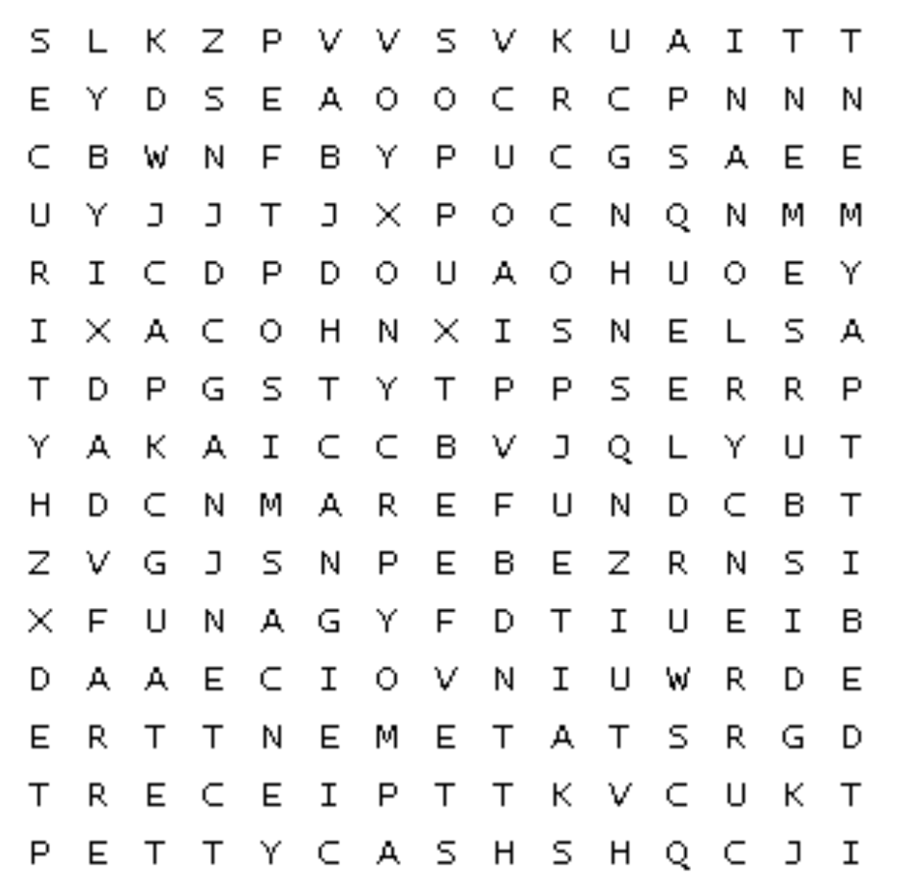

Find the words in the puzzle.
Words can go in any direction and share letters as they cross over each other.
accounting |  | cash |  | credit
currency |  | debit |  | disbursement
EFTPOS |  | GST |  | invoice
payment |  | paypass |  | pettycash
POS |  | receipt |  | refund
security |  | statement |  | tax
transactions |  | voucher

